Redux Toolkit and Mirage or Moking SERVER

Moking and mirage , server ke response or backened pe server se call karna front end pe frint development kage hain,same result like node js

YE server jesa look deta hai, Contain 4 option get , put, post and elete

Client phel banta hai q ke phir clent ke hasab se server bate hain

LINK:

<https://miragejs.com/quickstarts/react/develop-a-component/>

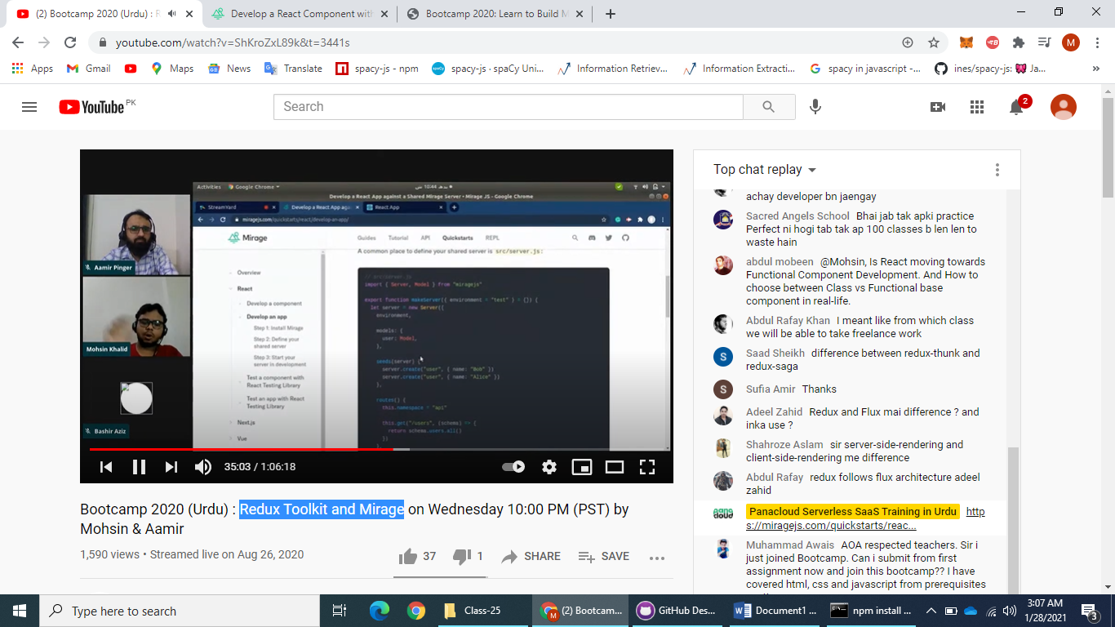

APP ke marze hai server or marag ke fiel ek main bano ya alag

STEP:

1. MAKE REACT PROJECT
2. npm install --save-dev miragejs
3. make server follow link or upper pic lekin un hon ek he feile main sever and client banalea hai ach hai agar alag alag bano so goto this link:

<https://miragejs.com/quickstarts/react/develop-an-app/>

1. make data.json file and import the file in server
2. call sever in index.js

EXTRS:

ADD=POST, GET=CALL data